**Hardware - Software Interface (HSI)**

**Kenodo-ElectricBlender (PO2_EBL)**

### DocumentStatus:Proposed

**Document status:**

|  |  |  |  |
| --- | --- | --- | --- |
| **Version** | **Status** | **Author** | **Date** |
| 1.0 | Draft | Mohamed Megahed  Esraa Mansour | 23/1/2020 |
| 1.1 | Proposed | Mohamed Megahed  Esraa Mansour | 5/2/2020 |

**DocumentHistory:**

|  |  |  |  |
| --- | --- | --- | --- |
| **Version** | **Author** | **Date** | **Change Description** |
| 1.0 | Mohamed Megahed  Esraa Mansour | 23/1/2020 | Initial Creation of HSI |
| 1.1 | Mohamed Megahed  Esraa Mansour | 5/2/2020 | * Reference table was added * REQID and direction to pin connections table were added * TAGID was changed to REQID * Unreverent details were removed from the ATMEGA32 section |
| 1.2 | Mohamed Megahed  Esraa Mansour | 5/2/2020 | * Document status table was added * Reference table format was edited |

**Reference Table:**

|  |  |  |  |
| --- | --- | --- | --- |
| **Ref. number** | **Doc. name** | **Version** | **Status** |
| 1 | CRS | 1.0 | Released |

# Table of Contents

Listoffigures 4

Listoftables 4

2.1 Block Diagram 5

2.2 Pins Connection 6

2.3 Components Description 6

# Listoffigures

|  |  |
| --- | --- |
| **Figure name** | **Page** |
| Block diagram | 4 |

# Listoftables

|  |  |
| --- | --- |
| **Table name** | **Page** |
| Pin Connections | 4 |

# Introduction

* 1. **Purpose**

ThisdocumentdefinestheHSIdatadictionaryforElectric Blender.

* 1. **Scope**

ThisdocumentdescribesthestructureoftheHSI.

1. **Requirements**

# Block Diagram

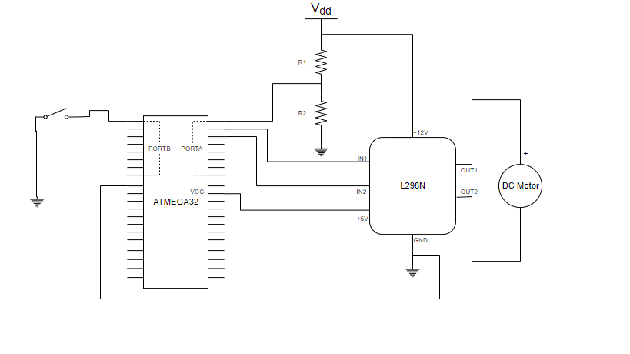

Figure 1 –Block diagram

# Pins Connection

# REQID:Req_PO2_EBL_Electric_Blender_HSI_001_1.0

|  |  |  |  |
| --- | --- | --- | --- |
| **Component** | **Pin Number** | **Connection** | **Direction** |
| ATMEGA32 | PINA0 | Voltage Divider | Input |
| PINA1 | Motor Driver (IN1) | Output |
| PINA2 | Motor Driver (IN2) | Output |
| PINB0 | Tactile Switch | Input |
| VCC | Motor Driver (+5V) | Input |
| GND | Motor Driver (GND) | - |
| Motor Driver | +12V | VDD | Input |
| 5V | ATMEGA(VCC) | Output |
| GND | ATMEGA(GND) | - |
| IN1 | PINA1 | Input |
| IN2 | PINA2 | Input |
| OUT1 | DC Motor (+) | Output |
| OUT2 | DC Motor (-) | Output |
| DC Motor | Terminal1(+) | Motor Driver(OUT1) | Input |
| Terminal2(-) | Motor Driver(OUT2) | Input |
| Tactile Switch | Terminal1 | GND | - |
| Terminal2 | PINB0 | Output |
| Voltage Divider | Terminal1 | VDD | Input |
| Terminal2 | PINA0 | Output |
| Terminal3 | GND | - |

Table 1 – Pins Connection

# Components Description

* + 1. Switch

This Component change the electric blender speed from Off -> Speed 1 ->Speed 2 -> Speed 3 to Offagain, it’s connected to ATMEGA32 PINB0 in pull up mode.

**REQID:** Req_PO2_EBL_Electric_Blender_HSI_002_1.0

* + 1. Motor Driver

This Component is used to supply the DC motor with enough current as microcontroller can’t supply enough current to rotate the motor.

It takes power from external power supply (VDD), it takes input from microcontroller through pins IN1 and IN2 and its output OUT1 and OUT2 is fed to the DC motor terminals.

**REQID:**Req_PO2_EBL_Electric_Blender_HSI_003_1.0

* + 1. DC Motor

This component takes its input from the motor driver and changes its speed according to that input.

**REQID:**Req_PO2_EBL_Electric_Blender_HSI_004_1.0

* + 1. Voltage Divider

This circuit consists of two resistances to drop down the power supply’s voltage to 5 volt.

**REQID:**Req_PO2_EBL_Electric_Blender_HSI_005_1.0

* + 1. ATMEGA32

This is the microcontroller the core of the process, it has two functions.

First function: it reads the input of the switch and according to that input it produces different wave forms with pulse width modulation (PWM).

Second function: The microcontroller reads the output voltage of the voltage divider to make sure that only the desired voltage range is delivered to motor driver.

**REQID:** Req_PO2_EBL_Electric_Blender_HSI_006_1.0